Destroy All Daleks User Guide

Our character’s name is Mathias, he is adult man living in a spaceship with his comrades. If you could describe Mathias role in the spaceship, that would probably the brave one from the group. The one that always guides the group and seems fearless to everyone. He is who people go to whenever something goes wrong because no matter the situation, he is always so calm about it.

Mathias comes from Norway and he loves his culture, he believes he was born in the wrong era and would’ve love to live as a viking. That is the reason he joined the spaceship crew, because his dream was to fight and protect his comrades and die in battle. His day came when the robots attacked, he helped as many people as he could evacuate, although he couldn’t save everyone. He was left behind when he decided to go back to help an already helpless comrade. He bravely faces all the robots that are to come to conquer the spaceship by himself. His fate was met.

**Controls**:

Pause - Esc

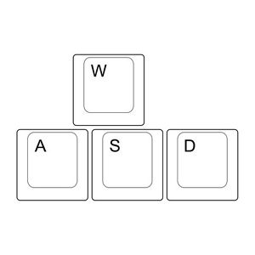 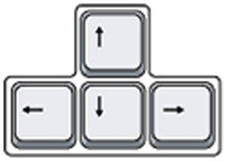 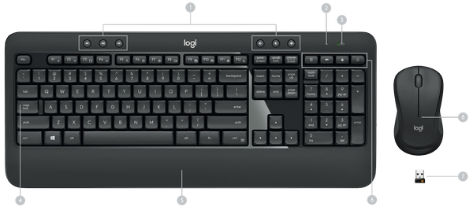

Move

Fire

Forward

Left, Back, Right

Left, Back, Right

Forward

Doors will open when you approach them.

**Objective**:

Kill Daleks and Survive